**Support Vector Machines (SVM):** Support Vector Machines (SVM) are a set of supervised learning methods used for classification, regression, and outliers detection. Here's an overview of the key concepts and functionalities of SVMs:

**Key Concepts**

1. **Hyperplane**:
   * In the context of SVMs, a hyperplane is a decision boundary that separates different classes. For a 2-dimensional space, this is a line; for a 3-dimensional space, it is a plane; and for higher dimensions, it's a hyperplane.
2. **Margin**:
   * The margin is the distance between the hyperplane and the nearest data points from each class, which are known as support vectors. SVM aims to maximize this margin to improve the model's robustness and accuracy.
3. **Support Vectors**:
   * These are the data points that are closest to the hyperplane and influence its position and orientation. They are critical elements in defining the optimal hyperplane.
4. **Kernel Trick**:
   * SVM can efficiently perform a non-linear classification using the kernel trick, implicitly mapping inputs into high-dimensional feature spaces. Common kernels include linear, polynomial, radial basis function (RBF), and sigmoid.

**Functionality**

1. **Classification**:
   * SVMs are primarily used for binary classification tasks. Given labeled training data, the SVM algorithm outputs an optimal hyperplane which categorizes new examples.
2. **Regression (SVR - Support Vector Regression)**:
   * SVM can also be adapted for regression tasks. Instead of finding a hyperplane that separates classes, SVR finds a hyperplane that predicts continuous values.
3. **Outlier Detection**:
   * SVM can also be used for detecting outliers in data, particularly useful in anomaly detection tasks.

**How SVM Works**

1. **Training**:
   * During training, SVMs find the optimal hyperplane that maximizes the margin between different classes. This is formulated as a quadratic optimization problem.
2. **Classification**:
   * Once trained, the SVM uses the hyperplane to classify new data points. If the data point lies on one side of the hyperplane, it is classified into one class; otherwise, it belongs to the other class.
3. **Handling Non-linear Data**:
   * For non-linearly separable data, SVM uses kernel functions to transform the original feature space into a higher-dimensional space where a hyperplane can be used to separate the classes linearly.

**Mathematical Formulation**

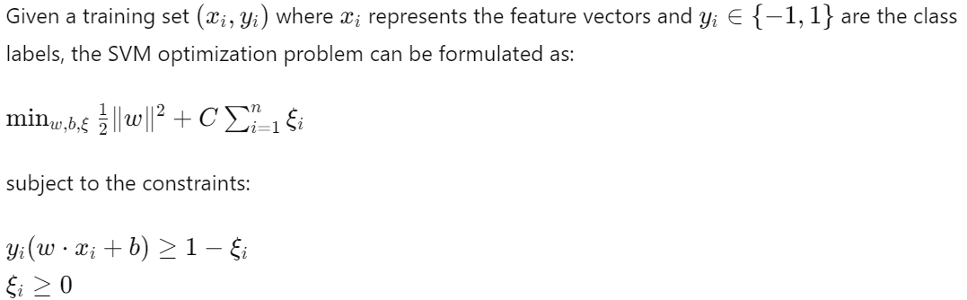

**Applications**

* Text categorization
* Image recognition
* Bioinformatics (e.g., gene classification)
* Handwriting recognition
* Face detection

**Advantages**

* Effective in high-dimensional spaces.
* Still effective when the number of dimensions is greater than the number of samples.
* Uses a subset of training points in the decision function (support vectors), making it memory efficient.

**Disadvantages**

* Not suitable for very large datasets due to high training time complexity.
* Performance depends on the choice of the kernel and the parameter settings.
* Less effective on noisy data and overlapping classes.

Support Vector Machines provide a powerful tool for classification and regression tasks, especially when dealing with high-dimensional data. Their ability to handle linear and non-linear separations, combined with robustness against overfitting, makes them a popular choice in various fields of machine learning and data science.

**Hard Margin:** A hard margin SVM is used when the data is linearly separable. This means that there exists a hyperplane that can separate the classes without any misclassifications.

**Characteristics**:

* **Strict Separation**: All data points must lie on the correct side of the hyperplane.
* **No Misclassifications Allowed**: The model does not tolerate any misclassifications or errors.
* **Margin Maximization**: The SVM finds the hyperplane that maximizes the margin, which is the distance between the hyperplane and the nearest data points (support vectors).

**Limitations**:

* Hard margin SVMs can only be applied to perfectly linearly separable data.
* They are very sensitive to outliers. A single outlier can significantly change the position of the optimal hyperplane.

**Soft Margin:** A soft margin SVM allows for some misclassifications or errors in the training data. This makes it suitable for datasets that are not perfectly linearly separable.

**Characteristics**:

* **Slack Variables**: Introduces slack variables ξi\xi_iξi​ to allow some data points to be on the wrong side of the hyperplane.
* **Trade-off Between Margin and Misclassification**: Balances the margin size and the number of misclassifications using a regularization parameter CCC

**Advantages**:

* Can handle datasets that are not perfectly separable.
* More robust to outliers compared to hard margin SVMs.

**Limitations**:

* The choice of the regularization parameter CCC is crucial and requires tuning.
* May still struggle with very noisy datasets where the classes are heavily overlapping.

**Summary**

* **Hard Margin SVM**: Suitable for perfectly linearly separable data with no tolerance for misclassifications. It maximizes the margin but is sensitive to outliers.
* **Soft Margin SVM**: Suitable for non-separable data, allowing some misclassifications to achieve a balance between margin maximization and error minimization. It introduces slack variables and a regularization parameter CCC to control this trade-off.

**Kernel**: Kernels allow SVMs to handle non-linearly separable data efficiently.

**Linear Kernel**:

* Use when the data is linearly separable or when you have many features.
* Fast and less prone to overfitting in high-dimensional spaces.

**Polynomial Kernel**:

* Use when interactions between features are significant.
* Higher-degree polynomials can lead to overfitting; parameter tuning is crucial.

**RBF Kernel or Radial or Gaussian Kernel**:

* Default choice when the relationship between the features and the target variable is complex and unknown.
* Effective in capturing the intricate structures within the data.

**Sigmoid Kernel**:

* Use when the problem domain suggests a model like neural networks.
* Less commonly used compared to RBF and polynomial kernels.

**Practical Considerations**

1. **Parameter Tuning**:
   * The performance of kernelized SVMs is highly dependent on the choice of parameters like CCC (regularization parameter), γ\gammaγ for RBF, and ddd for polynomial kernels.
   * Techniques like cross-validation and grid search are often used to find the optimal parameters.
2. **Computational Cost**:
   * Non-linear kernels (especially RBF) can be computationally intensive for large datasets.
   * Kernelized SVMs may not scale well to very large datasets.
3. **Interpretability**:
   * Models using linear kernels are easier to interpret compared to those using non-linear kernels.
   * Non-linear kernels transform the data into higher-dimensional spaces, making it difficult to visualize and understand the decision boundary.

**Label Encoder vs Ordinal Encoder vs OneHot Encoder**:

**LabelEncoder:** **Label encoding helps with preserving the target labels**

**Purpose**:

* Converts categorical labels into integer values.
* Typically used for encoding target labels in classification tasks where there is no inherent order among categories.

**Usage**:

* Suitable for target variables (class labels) in classification tasks.

**OrdinalEncoder: Ordinal encoding transforms categorical data into numerical**

**Purpose**:

* Encodes categorical features as integers with an assumed intrinsic order.
* Suitable for ordinal features where the order of categories matters (e.g., 'low', 'medium', 'high').

**Usage**:

* Used for encoding ordinal features in datasets.

**OneHotEncoder**

**Purpose**:

* Encodes categorical features as a one-hot numeric array.
* Suitable for nominal features where there is no intrinsic order among categories.

**Usage**:

* Used for encoding nominal features in datasets, converting each category into a separate binary column.

**Cross-validation:** This is a crucial technique in machine learning for evaluating the performance and generalizability of a model, including Support Vector Machines (SVM). It helps in mitigating overfitting and ensures that the model performs well on unseen data. Here's a detailed explanation of how cross-validation works in the context of SVM:

**Key Concepts of Cross-Validation**

1. **Training and Validation Split**:
   * The dataset is split into multiple subsets, with each subset serving as both a training set and a validation set in different iterations.
   * The model is trained on a portion of the data and validated on the remaining portion.
2. **Types of Cross-Validation**:
   * **k-Fold Cross-Validation**: The dataset is divided into k equal-sized folds. The model is trained k times, each time using k−1 folds for training and the remaining fold for validation.
   * **Stratified k-Fold Cross-Validation**: A variation of k-Fold that maintains the distribution of classes in each fold, which is useful for imbalanced datasets.
   * **Leave-One-Out Cross-Validation (LOOCV)**: Each data point is used as a validation set exactly once while the rest of the data points are used for training.
   * **Repeated k-Fold Cross-Validation**: Repeats the k-Fold cross-validation process multiple times to further ensure the reliability of the results.

**Steps for Cross-Validation in SVM**

1. **Choose the Type of Cross-Validation**:
   * Determine the most appropriate cross-validation technique based on the dataset and the specific problem. For example, stratified k-Fold is typically preferred for classification tasks with imbalanced classes.
2. **Initialize the Cross-Validation Method**:
   * Use scikit-learn’s cross-validation methods to create the splits.
3. **Train and Validate the SVM**:
   * Train the SVM model on the training set of each fold and evaluate it on the validation set.
4. **Aggregate the Results**:
   * Collect performance metrics (e.g., accuracy, precision, recall, F1 score) from each fold and compute the average to estimate the model's performance.

**Summary**

* **Cross-Validation**: Technique to evaluate model performance and generalizability by splitting the dataset into training and validation sets multiple times.
* **k-Fold Cross-Validation**: Most commonly used method, where the dataset is divided into kkk folds and the model is trained and validated kkk times.
* **Stratified k-Fold Cross-Validation**: Maintains class distribution, useful for imbalanced datasets.
* **Hyperparameter Tuning**: Cross-validation helps in selecting the best hyperparameters by evaluating different parameter combinations on the validation sets.
* **Implementation**: Use scikit-learn’s cross_val_score, GridSearchCV, or RandomizedSearchCV to perform cross-validation and hyperparameter tuning.

Cross-validation ensures that your SVM model is robust and performs well on unseen data, making it an essential step in the machine learning pipeline.